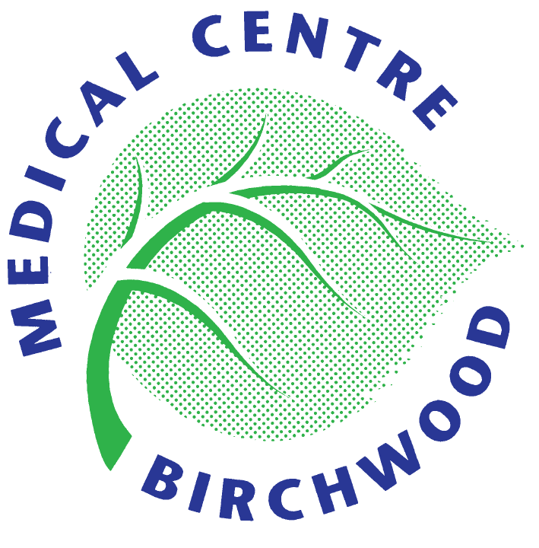
BIRCHWOOD MEDICAL CENTRE
New Patient Medical Questionnaire

(Please complete as much of this form as possible and bring to your New Patient Medical Appointment)
Name: | Date of Birth: Age:
Sex: Male / Female | Next of Kin:
Address: | Telephone Number:
 | Mobile:
Summary Care Record: YES / NO | SMS Text Consent: YES / NO
(Xab9D)Named GP: ( office use only) | Email address:

Please tick (√) the box that best describes your ethnic origin
White British □ White Irish □ Indian □ Chinese □
Pakistani □ Caribbean □ Bangladeshi □ African □
Other – Please specify _____________________________________________
First Language Spoken – Please Specify _______________________________
Height: | Weight: | BP:
Contraception: | Last Smear:
Illnesses/ Medical Condition:  (Please list all) | Allergies:
Smoker: YES / NO | British Military Service: Yes/No
Exsmoker: YES/ NO

Medication: |  | Chemist of choice:
We are able to send electronic prescriptions to any pharmacy of your choosing.
The chemists listed below are ones local to the surgery that you may wish to choose
 |  | Well Pharmacy – Birchwood Shopping Centre
 |  | Well Pharmacy – Fearnhead
 |  | Click Pharmacy
Family History  Does your mother, father, brother or sister have or has had: |  | Which Member? Age Diagnosed?
Heart Attack | YES / NO
Angina | YES / NO
Stroke | YES / NO
Kidney Disease | YES / NO
Diabetes | YES / NO

Do you drink alcohol: YES / NO If YES –
What is the average amount of units consumed per week: ______________________________
(e.g. 1 unit = 1 glass of wine = ½ a pint of beer or 1 unit = 1 measure of spirit
PLEASE CIRCLE THE ANSWER THAT APPLIES TO YOU:
1. How often do you have a drink that contains Alcohol | Never | Monthly or less | 2-4 times per month | 2-3 times per week | 4+ times per week
2. How many standard alcoholic drinks do you have on a typical day when you are drinking? | 1-2 | 3-4 | 5-6 | 7-8 | 10+
3. How often do you have 6 or more standard drinks on one occasion? | Never | Less than Monthly | Monthly | Weekly | Daily or almost daily

