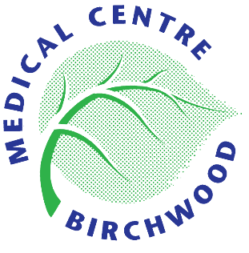
BIRCHWOOD MEDICAL CENTRE

Privacy Notice Information

General Practice Data for Planning and Research (GPDfPR) - data collection

NHS Digital has recently announced it is setting up a new primary care data collection service. The new data collection process is to begin from the
1st September 2021. (please note new start date, as original start date has been postponed until 1st Sept 2021.)

What is the GPDfPR?

The General Practice Data for Planning and Research data collection will help the NHS to improve health and care services for everyone.

For example, patient data can help the NHS to:
- monitor the long-term safety and effectiveness of care
- plan how to deliver better health and care services
- prevent the spread of infectious diseases
- identify new treatments and medicines through health research

How sharing patient data with NHS Digital helps the NHS and you:
The NHS needs data about the patients it treats in order to plan and deliver its services and to ensure that care and treatment provided is safe and effective. The General Practice Data for Planning and Research data collection will help the NHS to improve health and care services for everyone by collecting patient data that can be used to do this.
GP practices already share patient data for these purposes, but this new data collection will be more efficient and effective.
We have been asked to share the patient data we look after in our practice with NHS Digital who will securely store, analyse, publish and share this patient data to improve health and care services for everyone. This includes:
- informing and developing health and social care policy
- planning and commissioning health and care services
- taking steps to protect public health (including managing and monitoring the coronavirus pandemic)
- in exceptional circumstances, providing you with individual care
- enabling healthcare and scientific research
This means that we can get on with looking after our patients and NHS Digital can provide controlled access to patient data to the NHS and other organisations who need to use it to improve health and care for everyone.
Contributing to research projects will benefit us all as better and safer treatments are introduced more quickly and effectively without compromising your privacy and confidentiality.
NHS Digital has engaged with the British Medical Association (BMA), Royal College of GPs (RCGP) and the National Data Guardian (NDG) to ensure relevant safeguards are in place for patients and GP practices.
To view further information please click here to navigate to the NHS Digital Webpage which provides up to date information on the Data Collection.

Opting out of NHS Digital collecting your data
If you do not want your identifiable patient data to be shared outside of your GP practice for purposes except for your own care, you can register an opt-out with your GP practice. This is known as a Type 1 Opt-out. This should be done by returning this form to your GP practice by 23 August 2021 to allow time for processing it.
NHS Digital will not collect any patient data for patients who have already registered a Type 1 Opt-out in line with current policy. If this changes patients who have registered a Type 1 Opt-out will be informed. You can register a Type 1 Opt-out at any time. You can also change your mind at any time and withdraw a Type 1 Opt-out.
If you register a Type 1 Opt-out after your patient data has already been shared with NHS Digital (after 1 July 2021), no more of your data will be shared with NHS Digital. NHS Digital will however still hold the patient data which was shared with us before you registered the Type 1 Opt-out
If you do not want NHS Digital to share your identifiable patient data with anyone else for purposes beyond your own care, then you can also register a National Data Opt-out.

Agreed by Partners at Management Meeting on Monday, 17 May 2021

